Exercise 21: Route (ResourceID)

Objectives and Outcomes

Route parameters allow you to define dynamic segments in your route paths that can be accessed as props within the rendered component.

Exercises

1. Create a list of users and display their details upon clicking on the user's ID

const users = [

{ firstName: "John", lastName: "Done", age: 25 },

{ firstName: "Mary", lastName: "Thompson", age: 35 },

{ firstName: "John", lastName: "Smith", age: 30 },

{ firstName: "Emily", lastName: "Johnson", age: 25 },

{ firstName: "William", lastName: "Davis", age: 34 }

];



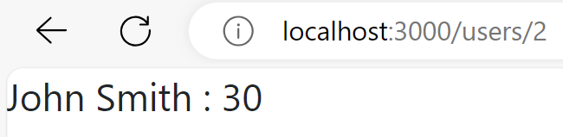

1. Create a list of dishes and display their details upon clicking on the dish's ID

"dishes": [

{

"id": 0,

"name": "Uthappizza",

"image": "images/uthappizza.png",

"category": "mains",

"label": "Hot",

"price": "4.99",

"featured": true,

"description": "A unique combination of Indian Uthappam (pancake) and Italian pizza, topped with Cerignola olives, ripe vine cherry tomatoes, Vidalia onion, Guntur chillies and Buffalo Paneer."

},

{

"id": 1,

"name": "Zucchipakoda",

"image": "images/zucchipakoda.png",

"category": "appetizer",

"label": "",

"price": "1.99",

"featured": false,

"description": "Deep fried Zucchini coated with mildly spiced Chickpea flour batter accompanied with a sweet-tangy tamarind sauce"

},

{

"id": 2,

"name": "Vadonut",

"image": "images/vadonut.png",

"category": "appetizer",

"label": "New",

"price": "1.99",

"featured": false,

"description": "A quintessential ConFusion experience, is it a vada or is it a donut?"

},

{

"id": 3,

"name": "ElaiCheese Cake",

"image": "images/elaicheesecake.png",

"category": "dessert",

"label": "",

"price": "2.99",

"featured": false,

"description": "A delectable, semi-sweet New York Style Cheese Cake, with Graham cracker crust and spiced with Indian cardamoms"

}]

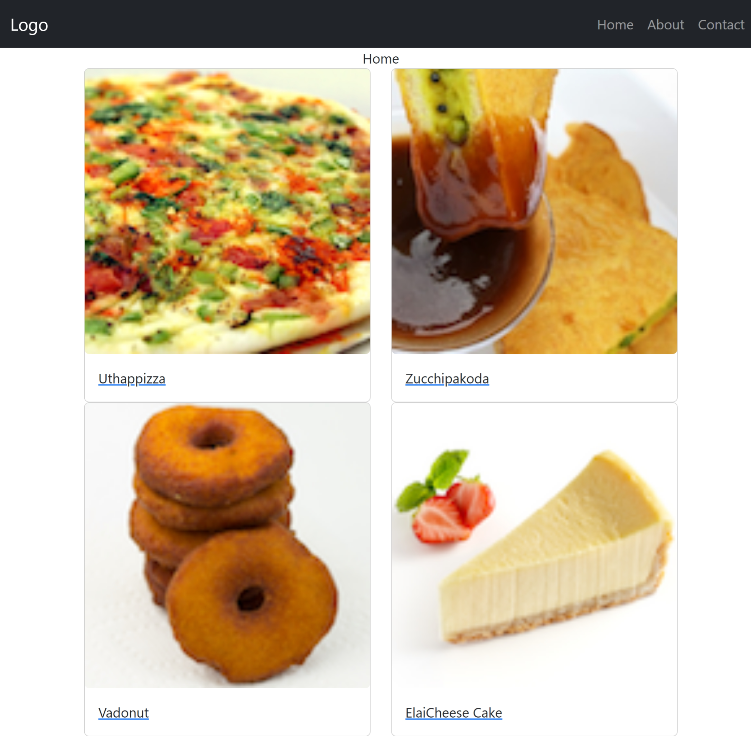

Conclusion

In conclusion, handling resource IDs in routes with React Router can be accomplished using route parameters.